Assessment and Growth

Overview
- Initial baseline work
- Annual standardised tests
- Wildings Assessment
- Formative assessments
- Aspirational targets
- Progress files
- Analysing progress
- Reporting to homes

- Initial baseline work
When a young person arrives at The Wildings, they will be inducted into the school community in a supportive and structured manner. The focus of this induction will be building relationships and completing a thorough baseline assessment. This process is expected to last around 6 weeks, but is very dependent on the individual and their needs. Colleagues will work together to build a comprehensive profile of the young person that includes personal details, academic, therapeutic, social and emotional aspects.
Core sources of information feeding into this profile could include:
- referral documents
- EHCP’s
- information from previous school(‘s)
- information from home
- information from social care
- GL Assessment progress tests in English, reading, spelling and Maths
- GL Assessment Cognitive Ability tests
- dyslexia screening results
- colleague academic baselining
- Thrive assessment
- Special Needs Assessment Profiling in social and emotional aspects of learning.
- Strengths and Difficulties questionnaire
- Emotional literacy investigations
This information will feed in to a virtual student profile and provide us with a starting point with which to measure progress across all areas.

- Standardised Progress Tests
We will run progress tests twice a year for each young person. The position in the year may be different, to reflect different times that a young person joined the school.
The tests will be conducted using GL assessment. They will provide information about three progress measures through the curriculum: Spelling, Reading and Maths. The tests give age equivalent and standardised scores.

The information gleaned from the test results will support:
- the measuring of the young person’s progress against national norms
- checking the appropriateness of the curriculum pathway followed
- the analysis and identification of strengths and weaknesses in respect of the Young person’s acquisition of key skills and knowledge.

- The Wildings System
As a generic expectation, young people are expected to make one stage of progress a year.

Stage | National curriculum year group | Wildings pathway
P1  P2  P3 | EY | Recovery
1 | 1 | Establishing
2 | 2
3 | 3 | Developing
4 | 4
5 | 5 | Enhancing
6 | 6
7 | 7 | Extending
8 | 8
9 | 9
10 | 10 | Specific
11 | 11

Each young person will be assessed as they progress through schemes of work. Greater weighting will apply at the conclusion of the scheme, where the young person will be expected to be able to demonstrate their learning. Each enquiry culminates in a ‘Challenge’ event in which the young person will contribute to and demonstrate the skills and knowledge they have gained. This piece of work will be assessed against the milestones of the enquiry by colleagues.

- Formative assessments
Formative colleague assessments take place in every learning experience.
Each young person will receive frequent feedback in order to celebrate achievement and identify next steps learning.
A young person will only be recorded as making sufficient progress through a curriculum pathway once colleagues are confident that the learning has been embedded.
A range of assessment techniques will be used to help colleagues check how well each young person is progressing. These include:

- Listening carefully to a young person’s answers to questions posed.
- Listening carefully to the questions posed by a young person.
- Observing how a young person engages in learning.
- Marking work, both during and after lessons.
- Noting how a young person responds to guidance provided during marking and verbal feedback.

- Aspirational Targets
Colleagues base targets on an expectation that each young person will maintain a parallel trajectory with ‘national’ from any given starting point.
Once colleagues are confident that the young person is on such a trajectory, greater aspiration can then be built in. Here, greater challenge will be seen in the day-to-day teaching. If a young person attains well, then the young person will be making up ground on his/her national counterparts.

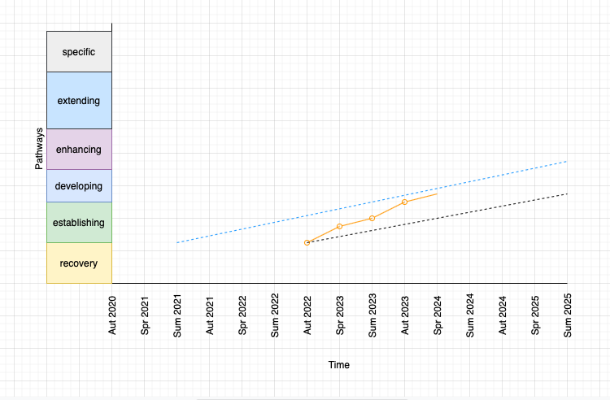

The graph helps to demonstrate ambition at The Wildings. The blue dotted line shows the liner trajectory for a ‘typical’ young person progressing through the national curriculum. Once a young person has been baselined, a starting point is established. The black dotted line is then projected, parallel to the blue ‘national’ line. The expectation is that the young person progresses along this trajectory. Through effective teaching and therapeutic provision, we hope to see the young person closing the attainment gap on ‘national’ – as shown by the solid orange line.

- YP Progress Files
For each young person, there is a portfolio of evidence kept to demonstrate progress in their academic work. This file is maintained for the duration of the young person’s placement. This means that progress can be seen over time and will be helpful informing teaching.
The Wildings colleagues will seek external moderation of progress files from local mainstream schools. It is expected that each portfolio will contain pieces of moderated work in English and Maths.

- Analysing Progress
The Wildings sets high academic standards. The initial baseline assessment determines which pathway a young person begins. Trajectories for each young person are created. These show what is expected at the end of the year. Colleagues reference these trajectories frequently to help inform changes in provision for each young person.

- Reporting to key adults
Key adults are invited into the school at the end of the autumn, spring and summer terms. Here, Wildings colleagues talk to the young person and his/her key adults about the learning undertaken since the last meeting.
Key adults receive a written report at the end of each academic term (3 times per year). This report includes information about the young person’s:
- progress through the curriculum
- attitude to learning
- conduct
- personal and social and emotional development

Key adults are invited to respond to the report. Colleagues reflect on this feedback and use it to inform the teaching strategy for the next academic year.

