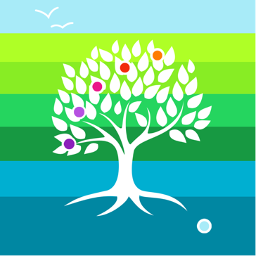
Curriculum Policy
Terminology:
School
The term “school” is used throughout. The nature of school as defined by The Wildings is made clear in the published Visions, Aims, Values and Standards Documentation and website information. This will also be reflected consistently and coherently in The Wildings constitution as a Community Interest Company (CIC) as detailed in “Office of the Regulator of Community Interest Companies: Information and guidance notes – Chapter 5: constitutional documents”.
Leadership and Governance
The terms “principal”, “governance” and “governance lead” are used throughout. The nature of leadership and governance for a Community Interest Company is detailed within the “Office of the Regulator of Community Interest Companies: Information and guidance notes – Chapter 9: corporate governance”.
Reporting
The term “reporting” is used throughout. It is made clear in the policies whether reporting is internal or external, compliance or quality assurance. Reporting obligations arising from being a CIC are detailed in “Office of the Regulator of Community Interest Companies: Information and guidance notes – Chapter 8: statutory obligations”.
Colleague
The term colleague is used throughout. This refers to members of staff within the school. Given the prominence of Social, Emotional and Mental health within the needs of our young people, therapeutically trained are included within this group alongside teaching staff.
Date of last update: September 2023
Contents:

- School context
- Ambition
- Curriculum intent
- Curriculum Implementation
- Curriculum Impact
- Academic Assessment
- Legal framework
- Roles and responsibilities
- States of Being
- PSHEE
- Equal Opportunities
- Engagement with Families outside of school hours
- Monitoring and review

- School Context:
The Wildings is an independent school. It meets the needs of young people with a primary need designated as social, emotional and mental health (SEMH). Young people are referred to us from Local Authorities after the breakdown of their current educational placements, usually due to their learning, social and emotional needs not being met. Most of these young people referred to us will have experienced trauma in some form.
All young people referred will have an education, health and care plan (EHCP). This plan will include information on their SEMH needs and any formal diagnosis that has been made. Common diagnoses include ADHD, ADD, ODD, ASD, Dyslexia, Dyspraxia, PDA and anxiety related issues. Each young person is unique, having unique needs.
Most referred young people need a different type of school setting because they do not feel safe, feel special or their needs are not being met. The Wildings curriculum meets their individual needs under a common framework. Many of our young people are in care and/or have social services involvement. Most young people are disengaged and disillusioned with education when they arrive with us.
All colleagues delivering this curriculum have extensive experience in multiple settings, working with young people designated with a primary need of SEMH. As a team, we have in-depth knowledge of trauma, attachment theory, child development, counselling, cognitive behavioural therapy, emotional development and emotional literacy. This, coupled with strong teaching knowledge, supports the young people in their recovery and growth.
Our curriculum is being further developed using an enquiry-led approach, using traditional subjects as states of being. This gives a sense of purpose to young people in applying skills and knowledge and enables broader opportunities to apply different knowledge and skills in different contexts, thus developing a more robust schema. For example, rather than being taught mathematics, young people will be expected to be mathematicians and demonstrate what they know and remember in different contexts
Our school is based in a wonderful, therapeutic environment with access to much outside space. The location is rural and will support connections with each other and the world around us. The Wildings caters for up to 20 young people, which enables a family community to develop. This supports the young people in building positive, trusting connections which help to ensure that everyone feels safe and supported.
We are developing a governance structure that will incorporate external and independent support. This group will provide challenge and include all stakeholders in the school community.

- Ambition:
All of our young people will:
- be keen to attend school and show this by having high levels of attendance
- gain successful and secure employment or further education
- become very self-aware
- develop a strong awareness of others
- develop and demonstrate a positive attitude to life
- develop independence skills for adult life
- develop self-esteem in order for them to be happy
- be curious
- form positive and appropriate connections with others
- be resilient
- be able to access the curriculum well, often through applying their strong reading skills
- effectively and appropriately communicate their needs
- become lifelong learners
- be healthy and understand what being healthy is both mentally and physically

In order to do this, we need to:
- provide an effective curriculum through which young people build knowledge, skills and understanding
- provide a personalised, purposeful curriculum which effectively motivates, engages each young person in order to fulfil their own wants and needs
- teach a personalised curriculum effectively
- provide an effective personalised recovery programme (personal, emotional and academic recovery)
- enable each young person to make strong progress through the curriculum.
- track each young person’s progress through their curriculum robustly, and to use this to inform teaching and therapeutic provision
- champion diversity and difference for all our young people
- ensure that colleagues develop strong subject and pedagogical knowledge through effective training
- ensure that young people re-visit aspects of the curriculum in order to secure knowledge and understanding
- prioritise each young person’s social, emotional and mental health growth, hence underpinning our curriculum with PSHEE.
- enable our young people to make informed decisions in order to keep themselves and others safe

- Curriculum intent
Given our context and ambition, the intent of our curriculum is for our young people to see themselves as learners with a desire to, and be able to, learn effectively.
Our curriculum is designed to support young people to recover socially, emotionally and academically (notably linguistically and numerically) and in a way that is different to what they have experienced in previous settings.

That is why we:
- strive to develop each young person’s self-motivation, moving towards a curriculum that fosters interest, long term relevance and therefore self-motivated young people
- develop direction and long-term goals that are relevant to each individual
- use the National Curriculum to underpin the development of each young person's individual program.
- use states of being to signpost learning areas.
- use enquiry-led learning to re-engage disaffected young people
- deliver cultural and topical experiences spread out through the year.
- underpin all experiences with our core subject of PSHE education.
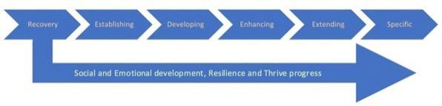
It is expected that each young person arriving at The Wildings will require a phase of recovery, expected to be no more than 12 weeks, but typically 4 to 6 weeks. During this phase, we will build connections with them and undertake baselining of their development stage, socially, emotionally and academically. From here, as they recover and grow, they will move through phases as detailed below:

Those young people that have experienced more severe trauma are likely to need an extended recovery phase. It is the aspiration that all young people engage in formal qualifications which will relate to the pathway they take as they move through our curriculum. These qualifications will be delivered in the specific phase.
The recovery phase will develop into a program of social and emotional development that will run alongside a young person’s academic and vocational experiences and support strong, holistic growth throughout their time at The Wildings.
A young person may move out of the recovery phase, but we often find that deeper trauma can surface as young people feel safer and develop trust within school. This could indicate that they need to return to this phase at any given time.
We aim to support our young people to gain far more than the ability to read, write and calculate, important as these skills are. We will support them to think for themselves, to work and live together, to build positive and supportive relationships, find meaning within their lives, in what they are learning and be able to work and live together. We will facilitate experiences that are diverse and will foster a growing sense of self, a direction and relevance within the learning and provide a real direction and improved trajectory for each of our young people.

Therapeutic Curriculum
The Wildings provide a range of specialist emotional and therapeutic support to young people, facilitated by our professional and experienced team.
Support is provided to all young people in a variety of different ways. We take time in building connections with young people, to begin to form a trusting, professional relationship, from which we seek to repair the past relational trauma. As a trauma informed provision, we have adults who are emotionally available to young people should they need support throughout the day. We also have scheduled pastoral sessions that can be accessed individually or through small groups, once trust has been developed in all parties.
Therapy forms a large part of many young people’s EHCPs and as such we have robust procedures where EHCP outcomes are monitored closely by our colleagues. Frequent meetings are held to review EHCP implementation plans to ensure all EHCP outcomes are on target and appropriate.

- Curriculum Implementation:
Term structure
All young people will follow a discrete program for English and Maths with 4 lessons of each per week. Phonics is taught within English using Read Write Inc and all young people will go through a through baseline of their phonics knowledge, with a program to fill any gaps produced by this. All young people will work towards AQA functional skills qualifications. Mathematics is taught using White Rose Maths, with young people working towards AQA Entry Level certificates before moving on to Level 1 and 2 Functional Skills. This will be complemented by a framework of Curious City enquiries. All young people will have regular PSHE and Wellbeing lessons within their weekly timetable. Within Curious city, they might follow the pathway of Year 5 enquiries within the ‘Enhancing’ phase of the framework. This means that young people will experience the full breadth and depth of the national curriculum, building on prior learning that they bring with them as they move through the enquiries. This approach also provides a progressive framework where the following year they can move through the Year 6 enquiries, consolidating and developing skills further in different contexts. There is also an opportunity through assessment that they might move into a new phase. All young people will progress on to AQA Entry Level Science qualifications in the specific stage.

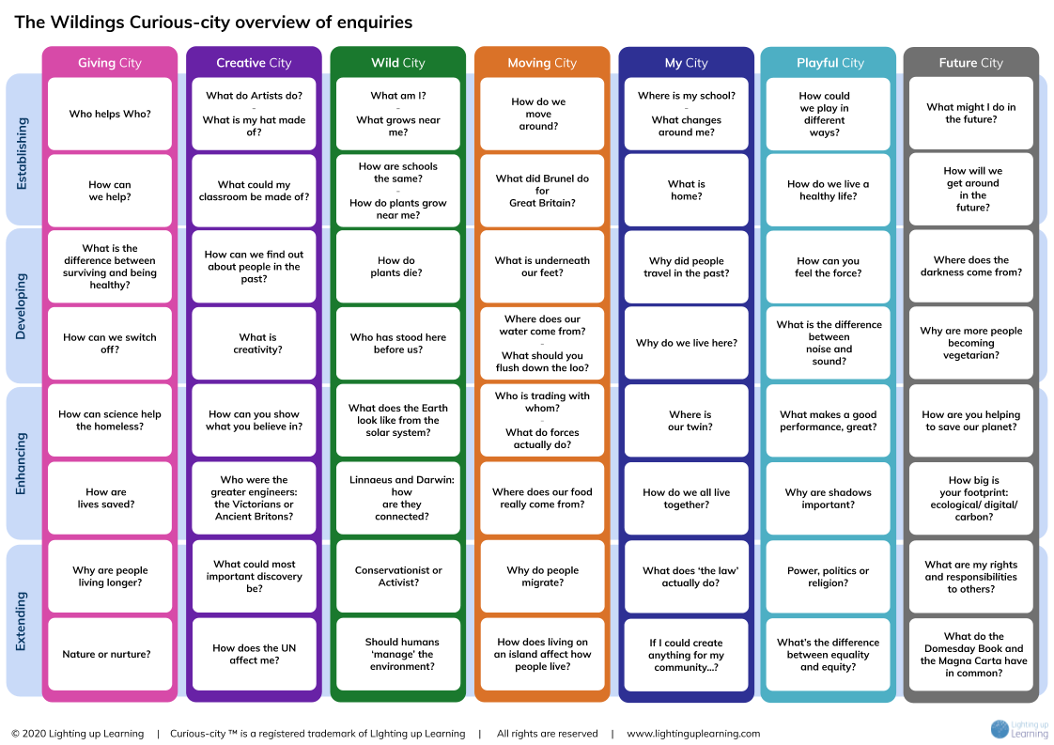

Which subjects are compulsory within the national curriculum and where?
Subject | Key stage 1 | Key stage 2 | Key stage 3 | Key stage 4
English | Yes | Yes | Yes | Yes
Maths | Yes | Yes | Yes | Yes
Science | Yes | Yes | Yes | Yes
Art & design | Yes | Yes | Yes
Citizenship |  |  | Yes | Yes
Computing | Yes | Yes | Yes | Yes
Design & technology | Yes | Yes | Yes
Languages |  | Yes | Yes
Geography | Yes | Yes | Yes
History | Yes | Yes | Yes
Music | Yes | Yes | Yes
PE | Yes | Yes | Yes | Yes
RE | Yes | Yes | Yes | Yes

The entitlement of the young people will be based upon the national curriculum. Each young person will have access to a balanced set of experiences spread through the school year that are mapped through the national curriculum programs of study and incorporated into the enquiries. These experiences will be tailored to the enquiry that is being studied at that point. Each enquiry provides a clear progressive framework that immerses and challenges young people to demonstrate what they are learning whilst also providing enough time and space to personalise for each young person.
The enquiries are mapped under seven ‘cities’. A city is a geographical metaphor for an area of which the school is the centre. Each theme is a lens to see the world through, and means that states of being within enquiries are applied to different contexts. For example, Wild City being more focused on the natural world, Giving City on altruism or Moving City on how the world is connected through movement of people, transport and goods.
Our states of being relate to the national curriculum subjects in the following way:
State of Being | NC Links
Philosopher | PSHEE/Citizenship/RE
Author | English
Mathematician | Maths
Scientist | Science
Athlete | PE
Geographer | Geography
Historian | History
Artist | Art
Musician | Music
Engineer | Computing/Design and Technology
Linguist | Modern Foreign Languages

PSHEE is of paramount importance to our young people. We will therefore teach this as a discreet entity, whilst also including aspects of the state within enquiries as the Philosopher. We will teach Religious Education, Citizenship and aspects of the therapeutic curriculum, including Thrive activities through cross curricular lessons and termly cultural days.
Young people come to us with a wide range of prior learning and experiences. We take sufficient time to baseline their academic and emotional functioning. This enables us to place each young person into a pathway. These pathways are named:
Recovery
Establishing
Developing
Enhancing
Extending
Specific

As an Example:
Young person A is baselined and begins their curriculum pathway in term 2. They enter the curriculum in the Establishing phase and begin with a Wild City enquiry, ‘How Do Plants Grow Near Me?’ where being a Scientist, Artist and Geographer are the main states of being focussed on and National Curriculum objectives are clearly mapped and included below.

Term 2 Level: Establishing
Wild City: How do plants grow near me?
Lead State of Being: | Scientist
Secondary State of Being: | Artist
Secondary State of Being: | Geographer
Supporting States of Being: | Author, Mathematician and Engineer

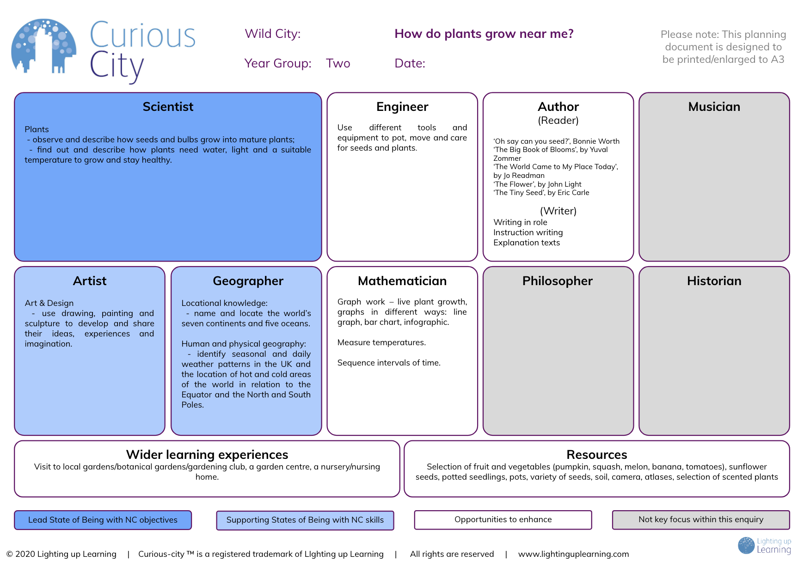

These objectives are then combined under a driving question and a challenge which will enable young people to provide an answer to the question both verbally and physically demonstrating.

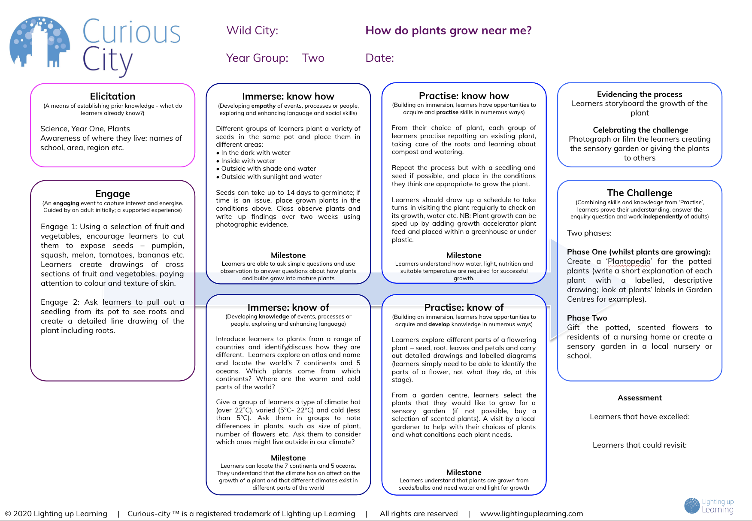

Following on from this, they engage in a Moving City enquiry, ‘What did Brunel do for Great Britain?’

Term 2/3 Level: Establishing
Moving City, What did Brunel do for Great Britain?
Lead State of Being: | Historian
Secondary State of Being | Engineer
Supporting State of Being: | Author
Supporting State of Being: | Mathematician

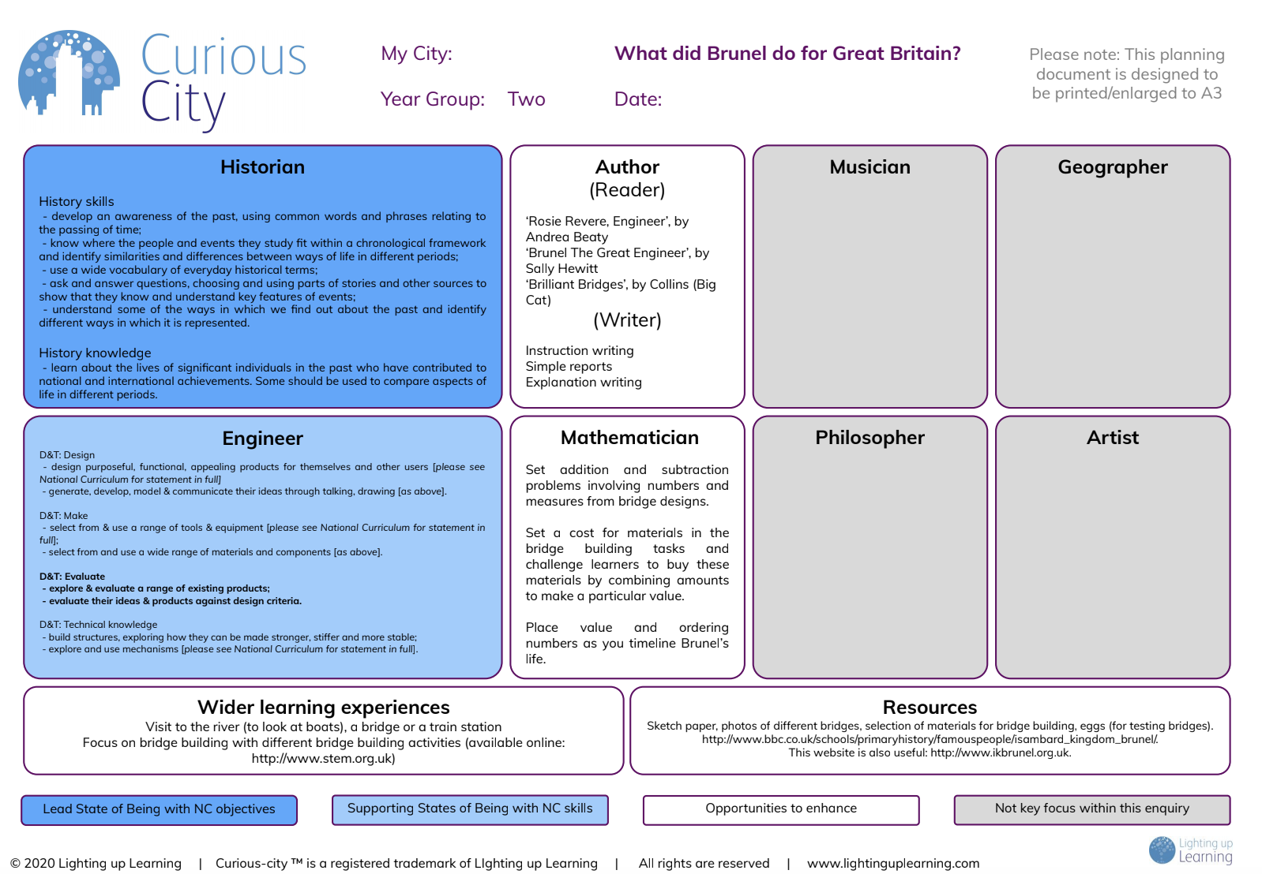
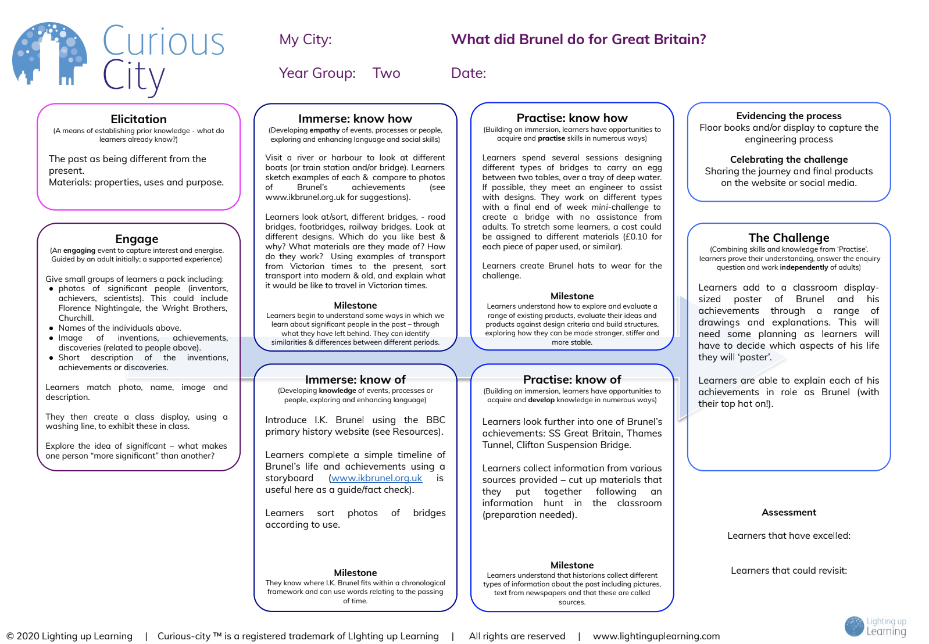

Young person B is baselined and begins curriculum pathway in term 4. They enter the curriculum in the Extending phase and begin with a My City enquiry, ‘If I could create anything for my community….?’

Term 2/3 Level: Extending
My City: If I could create anything for my community….?
Lead State of Being: | Geographer
Secondary State of Being | Artist
Supporting State of Being: | Author
Supporting State of Being: | Mathematician

Following on from this, they engage in a Playful City enquiry, ‘What is the difference between equality and equity?’

Term 2/3 Level: Extending
My City: ‘What is the difference between equality and equity?
Lead State of Being: | Philosopher
Secondary State of Being: | Historian
Secondary State of Being: | Author
Supporting State of Being: | Mathematician

We have identified the key component pieces of knowledge and skills which young people need to acquire for each subject. We use this information to help us sequence the curriculum in each subject. This will clarify the recapping of learning of the component pieces.

Therapeutic curriculum
Each young person will have a personalised therapeutic pathway that runs alongside their academic pathway. This will target the SEMH needs identified in their EHCP. Some examples of therapy available to our young people include (although not limited to):
- Thrive
- CBT
- Solution Focused Coaching
- Trauma Informed Mentoring
- Emotional Literacy
- Mindfulness
- Counselling services
Through the personalised assessments of the young people, where the thoughts, feelings and observations of the young person, their family and professionals are all taken into consideration, the young person can then build their own personalised toolkit to call on in times of need. At the beginning of a programme the young person will complete a self-assessment questionnaire. In order to track the effectiveness and the impact of the programme there is a further self-assessment questionnaire to complete at the end of the programme.
Due to the nature of our young people and the significant traumas that they would have experienced through their childhoods the recovery programme will continually be a focus for them. There will be times where we revisit specific strategies in order to strengthen the muscle memory in order for this strategy to become “second nature” to the young people. They will be able to call on their personalised toolkit in times of crisis in order to rectify traumatic situations, and to ultimately prevent the trauma re-recurring.
Progress will be measured through Thrive, SNAPB assessments and EHCP implementation plan trackers.
Partnerships
At the Wildings, a young person's health and well-being is of pinnacle importance. With this in mind The Wildings promotes multi-agency working. The Wildings team have long standing links between educational settings, services, agencies and the community that help to improve the educational achievement, the health and the social choices of young people and their families. We maintain and develop these links in order to support each young person in the five every child matters outcomes:
- Being Healthy: So that they are physically, mentally, emotionally and sexually healthy, have healthy lifestyles and choose not to take illegal drugs
- Staying safe: from maltreatment, neglect, violence, sexual exploitation, accidental injury and death, bullying and discrimination, crime and anti-social behaviour in and out of school, have security and stability and are cared for.
- Enjoying and Achieving: so that they are ready for school, attend and enjoy school, achieve stretching national educational standards at primary and secondary school, achieve personal and social development and enjoy recreation.
- Making a Positive Contribution: so that they engage in decision-making, support their community and environment, engage in law-abiding and positive behaviour in and out of school, develop positive relationships, choose not to bully and discriminate, develop self-confidence, successfully deal with significant life changes and challenges and develop enterprising behaviour.
- Achieving Economic Well-being: so that they engage in further education, employment or training on leaving school, are ready for employment, live in decent homes and sustainable communities, have access to transport and material goods., live in households free from low income.
In order to inform our provision in respect of these outcomes, The Wildings will ensure partnerships with a variety of professionals, including (but not limited to):
- referring local authorities
- Devon County Council Social Care
- Devon County Council LADO (Local Area Designated Officer)
- Police
- MASH (Multi-Agency Safeguarding Hub)
- Y-SMART (Drug and alcohol services for under 18’s)
- YIT (Youth Intervention Team)
- YOT (Youth Offending Team)
- Rights for Children (Devon Early Help Service)
- Educational Psychology Service (Babcock)
- School Nurses
- Young Devon (counselling, runaways, homelessness, abuse)
- Balloons (Grief Counselling)
- Check Point (drug and alcohol counselling, runaways, homelessness, abuse)
- Domestic Abuse Service
- SENDIASS (Special Educational Needs and Disabilities Information Advice and Support Services)

The Wildings colleagues will also be able to signpost young people to alternative means of support should this be necessary. We will support our young people to feel empowered if they have concerns around their peers in the community. Having this information will empower our young people to help others and this will include (but not limited to):
- Childline
- NSPCC
- Kooth
- Samaritans
- SENDIASS
- Devon Domestic Abuse Service
- Police

Timetabling
A typical day will look like this:
Time | Session | Content
08:30 - 08:45 | Colleague briefing | Update on outcomes from previous debrief, news from homes
08:45 - 09:00 | Arrival | Young people arrival by taxi and transition into school
09:00 - 09:30 | Breakfast | Communal breakfast in kitchen. Connection time and community purpose
09:30 - 10:15 | Session 1 | Instruction session with colleagues
10:15 - 11:00 | Session 2 | Instruction session with colleagues
11:00 - 11:20 | Break | Communal snack and reconnection centred around kitchen
11:20 - 12:00 | Session 3 | Instruction session with colleagues
12:00 - 12:40 | Session 4 | Instruction session with colleagues
12:40 - 13:30 | Lunch | Communal lunch with communication and social focus around the meal table
13:30 – 13:45 | Reading | Whole school reading session
13:45 – 14:20 | Session 5 | Instruction session with colleagues
14:20 – 15:00 | Session 6 | Instruction session with colleagues
15:00 - 15:15 | Taxi | Transition to taxis to return home
15:15 - 16:00 | Colleague Debrief | Colleagues debrief from the day, share relevant information and progress.

A typical week could look like this:
 | Monday | Tuesday | Wednesday | Thursday | Friday
Session 1 | Champion Time | English/Author  (Phonics) | English/Author | Wellbeing | English/Author  (Phonics)
Session 2 | Curious City  (Historian) | Philosopher  (Thrive/PSHE) |  | Author  (Phonics) | School Meeting
Break | Social | Social | Social | Social | Social
Session 3 | Mathematician | Curious City  (Geographer) | Enquiry  (Author, Athlete, Geographer) | Mathematician | Enrichment
Session 4 | English/Author  (Phonics) | Mathematician |  | Enquiry (Historian)
Lunch | Current Affairs | Current Affairs | Current Affairs | Current Affairs
Reading | Reading | Reading | Reading | Reading
Session 5 | Wellbeing | PE | Mathematician | Outdoor Education
Session 6 | IT | Forest School | DT/Art
Taxi | Taxi | Taxi | Taxi | Taxi | Taxi

Discrete Author teaching occurs at least four times per week and Mathematician at least three times per week. Application of Authors and Mathematicians are also woven into the Enquiry session. Whilst the national curriculum is covered within the enquiries, we complement this with discrete, core skills teaching using resources such as Accelerated Reader and White Rose Maths.
Given the importance of early reading, we have engaged with Read Write Inc. to ensure that a robust phonics provision is in place. To protect the dignity of our young people, our whole school training is focussed on the Fresh Start program. This extends to further reading provision, where we are working with the Renaissance Accelerated Reader program to align appropriate challenge within materials with age-appropriate content.
Enquiry sessions are times where certain states of being, e.g. historian, are focused on depending on the enquiry in question.
IT/Computing is a specific, regular weekly session, working through related skills and knowledge for the workplace.
PE and Outdoor Education will be delivered weekly, in a personalised format and also be incorporated in to enrichment activities that include mountain biking, kayaking, raft building etc.
The timetable is constructed to recognise how more integrated learning occurs earlier in the week and more discreet teaching towards the end of the week to recognise the cognitive load on young people and build in opportunities to revisit learning later in the week.
The Wellbeing sessions are delivery of the personalised therapeutic curriculum. They are specifically designed to support development in the SEMH needs of each individual, as detailed in their EHCP. This is underpinned with SMSC.
Social activities at break times will be facilitated by colleagues and be used to develop a community feel to the school as well as addressing social targets for each young person.
Current Affairs discussions will be facilitated by colleagues during the lunch break around the communal dining table. These will focus on ethical issues raised by what is in the news. Equality and Democratic values will support daily conversations, supporting each young person’s SMSC development in the young people.
Champion Time is a reflective period that young people will document their learning through the week, using a medium that is accessible to the young person. Reflective Diaries are the primary method of recording and reflecting on knowledge explored and skills experienced through the week, with supported reflection and formative feedback.
Enrichment sessions on a Friday are an opportunity to develop social skills, to experience group offsite activities and develop skills for independence. These often take the form of physical activities and will be linked to an area of the curriculum.

- Curriculum Impact:
The impact of our curriculum is under constant review. We frequently reflect on each young person’s curriculum offer and periodically review The Wildings curriculum. Subsequent adaptations help to ensure that the curriculum appropriately meets the changing needs of our young people, supporting and challenging the young people to achieve their full potential, both academically and emotionally.
The curriculum is frequently monitored by:
- analysing the outcomes of young people, including daily attendance monitoring
- sharing information via daily colleague meetings
- listening to feedback from parents, young people and significant professionals who supports the young person and their family
- facilitate parents/carers review meetings on a termly basis
- observing teaching and learning
- reflecting on learning walks
- conducting work scrutiny
- learning from case studies of young people
- re-assessing and quizzing young people for appropriate academic levelling
- re-assessing and questioning families, young people and significant professionals to complete after specific therapeutic programmes have been completed, such as solution focused coaching
- completing termly Thrive assessments and sharing with young people, families and significant professionals
- discussions with young people
- daily monitoring and observations by all colleagues, recorded on CPOMS
Therapeutic curriculum impact
The Wildings colleagues measure the impact of the therapeutic curriculum using:
- frequent self-assessment
- Thrive assessments
- SNAPB Assessments
- collaboration with families/parents/carers and other professionals
- attendance analysis – both to specific states of being and in general attendance to school
- incidents measured and analysed through CPOMS both a reduction in negative incidents and an increase in positive interaction
- working with other professionals to measure incidents within the community
- engagement in learning within sessions through CPOMS
- CPOMS reports on social interactions
- discussions with young people, their families, professionals and through observation to assess increases in confidence, self-esteem, motivation and generally happiness
When a young person completes these programmes of study, that run as part of their broad and balanced and relevant curriculum, we will see a young person grow holistically. Our intention is for young people to steepen their progress trajectory and achieve the following:
- academic ability, in line with their peers and their personal ability
- attendance to reach a minimum of 97.5%
- negative incidents to be considerably reduced
- growth of positive interactions
- zero negative incidents in the community
- be healthy
- stay safe
- enjoy and achieve
- make a positive contribution
- achieve economic well-being
- maintain consistent positive relationships with others
- maintain positive and consistent engagement in academic states of being
- become a lifelong learner
- secure and maintain employment, or to move on to higher education studies
We will evaluate the effectiveness of our entire curriculum by measuring, recording and analysing the following:
      - attitudes to learning
      - attendance
      - emotional growth
      - academic growth
      - how well are they developing schema

- Academic Assessment
Initial baseline work
When a young person arrives at The Wildings, s/he will be baselined for national curriculum subjects within 6 weeks. For English and Maths, this includes standardised testing as well as teachers’ assessment of the young person’s work during those 6 weeks. The process takes into account referral document information. For other subjects, where there are no appropriate tests, the focus is on teachers’ assessment of the YP’s work during the first 6 weeks. This information will be electronically stored in the young person’s assessment file.

Annual Standardised Tests
At least twice a year, all young people will be tested using the same group of tests used for baselining. These cover: spelling, reading and numeracy. The tests give either the age equivalent or standardised score. The standardised tests give an indication of the chronological age the young person is working at and an additional measure of progress against national norms.

Enhanced case studies
The system has been designed taking into account the needs of the young people who attend The Wildings. Termly reviews (3 times per year) provide opportunities to assess to what extent the young person ‘knows more and remembers more’ against the objectives experienced within our holistic curriculum. English and Maths progress is measured alongside national curriculum levels. Foundations subject progress is assessed through the curious city framework. Where learners have excelled or perhaps need to revisit objectives are noted on the enquiry planning and cross referenced with the curriculum coverage grid. The grid below shows an example (Historian) where the objectives are experienced again within the curriculum and so when the young person revisits the objectives, particular focus will need to be given in order to secure understanding.
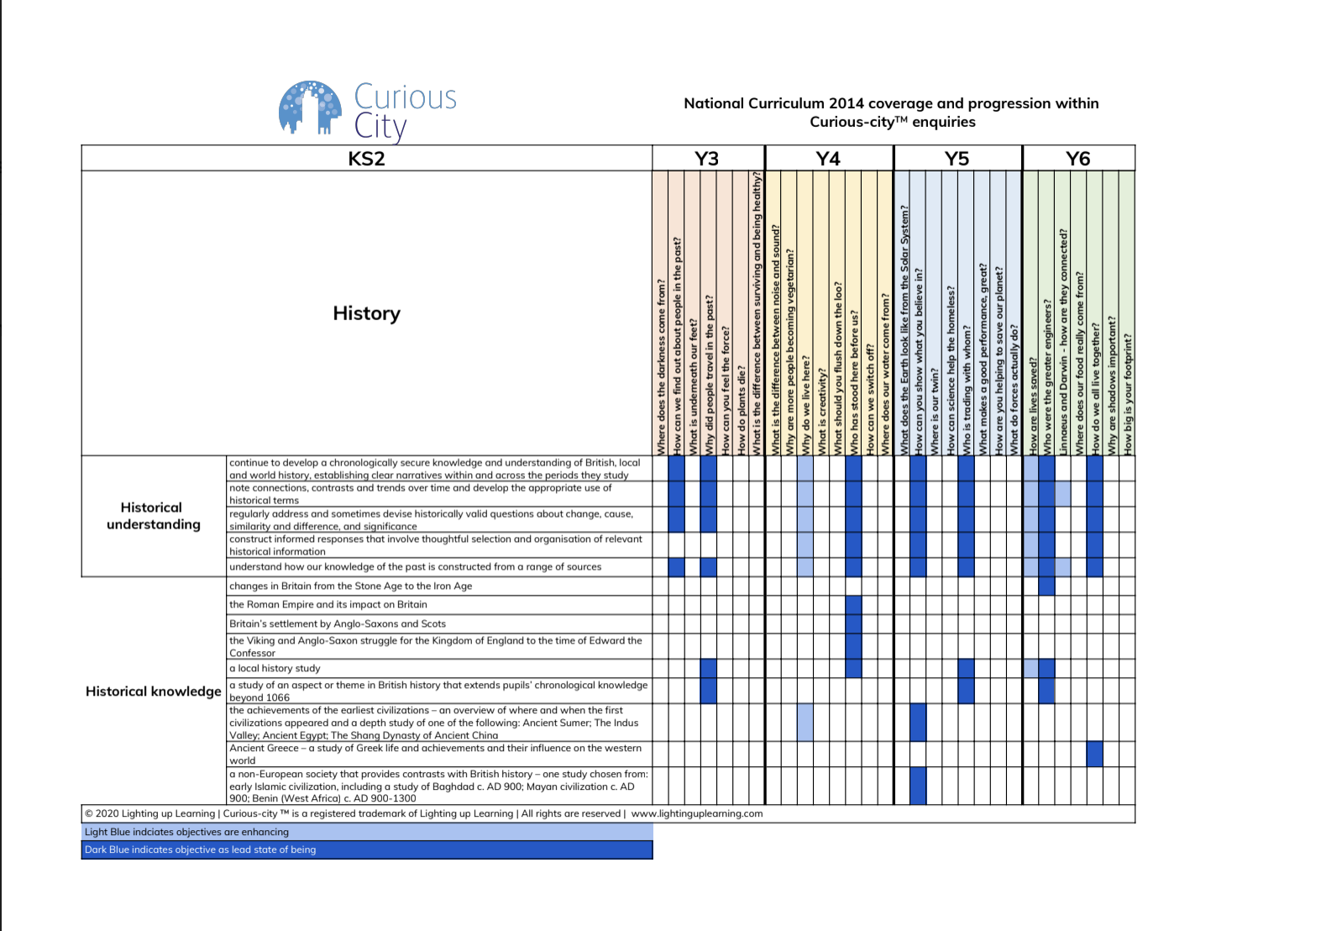
Formative assessments
Formative assessments take place in every lesson. Regular feedback to each young person will inform each young person of achievement and next steps.

Summative Assessments
Summative assessments take place twice during the academic year – the timing of these will be specific to the individual young person and directly related to their start date with us. Colleagues use this summative information to inform their assessment of each young person’s progress. This assessment (points) is then recorded. As the trajectory evolves, colleagues will be well placed to consider the effectiveness of the curriculum offer for each young person and where changes need to be made.

Aspirational Targets
Colleagues base targets on an expectation that each young person will maintain a parallel trajectory with ‘national’ from any given starting point. Once colleagues are confident that the young person is on such a trajectory, greater aspiration can then be built in. Here, greater challenge will be seen in the day-to-day teaching. If a young person attains well, then they will be making up ground on his/her national counterparts.

Moderation
Colleagues meet to discuss their judgements of each young person at least every half term. A range of information will inform these moderation meetings, including work scrutiny. Where possible, Wildings colleagues will be joined by subject specialist colleagues from local mainstream schools to help ensure that moderated judgements are accurate. For English and Maths, examples of teachers’ assessments will be evaluated by an external moderator at least once a year.
In each young person’s file, there will be evidence of moderated work.

Young people’s Enhanced Case Study Progress Files
For each young person, there is a file of evidence kept to demonstrate progress in their academic work. For Author and Mathematician there will be at least one piece of assessed work every half term. For some subjects, the evidence may take the form of a photograph or other means. This file is maintained for the duration of the young person’s placement. This means that progress can be seen over time and will be helpful in informing teaching. Baseline information will be helpful in determining how well each young person is progressing through the curriculum.

Analysing Progress
The Wildings sets high standards. An expected progress model is defined. The initial baseline assessment determines which pathway a young person begins. Clinical intervention is valuable in providing additional evidence to support teachers’ assessments. This is most notably where a young person remains in the recovery or establishing pathway. Trajectories for each young person are created. These show what is expected at the end of the year. This expectation is ambitious. Most young people arrive at the school on a significantly lower trajectory. We build further ambition by working with each young person in helping them close the attainment gap with their peers nationally. Colleagues reference these trajectories frequently to help inform changes in provision for each young person

An example of a trajectory graph:

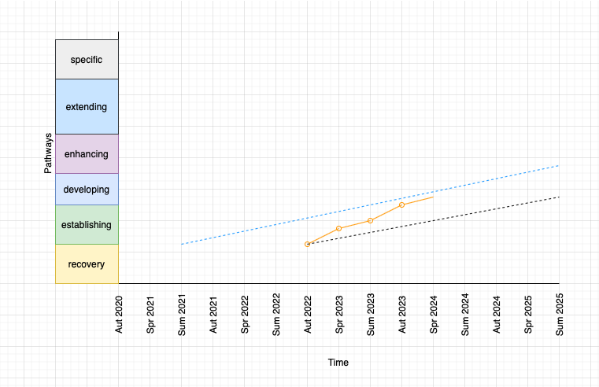

- Legal framework
This policy has due regard to all relevant legislation and statutory guidance including, but not limited to, the following:
    - The Education Act 2002
    - The Children Act 2004
    - The Equality Act 2010
    - DfE (2017) ‘Special educational needs and disability code of practice: 0 to 25 years’
    - DfE (2013) ‘The national curriculum in England’
    - DfE (2017) ‘Statutory framework for the early years foundation stage’
    - DfE (2019) ‘School attendance’
This policy operates in conjunction with the following school policies:
    - Equal Opportunities Policy
    - PSHEE Policy
    - Relationships and Health Education Policy
    - SEND Policy
- Roles and responsibilities
Roles within the school:
Mike is Principal and oversees the curriculum and mathematics teaching.
Mel is SEMH lead and oversees this aspect of the provision, along with therapeutic mentoring and wellbeing provision.
Karen leads on the recovery phase, PSHEE lead and is our lead thrive practitioner, supporting with emotional development interventions.
James leads on English and Phonics provision.
Steve leads our Curious City curriculum and PE.
Tom leads our vocational, outdoor education and forest school provision.
Naomi supports mathematics and leads DT and art.

Governance is responsible for:
    - approving and monitoring this policy.
    - liaising with the Principal and colleagues with regards to young people’s growth.
    - assisting the school with the creation and implementation of the curriculum.
    - checking the curriculum is inclusive and accessible to all.

The Principal is responsible for:
    - devising long and medium-term plans for the curriculum in collaboration with colleagues and other members of the school community.
    - communicating the effectiveness of the agreed curriculum to Governance on a termly basis.
    - ensuring the curriculum is inclusive and accessible to all.
    - assisting colleagues with the planning and implementation of the curriculum, ensuring their workload is manageable.
    - ensuring the curriculum is implemented throughout the school and ensuring any difficulties are addressed and mitigated as soon as possible.
    - receiving and analysing reports on the growth of young people and reporting these results to Governance.
    - together with colleagues, making any necessary adjustments to the curriculum where required.
    - keeping up-to-date with any relevant statutory updates and taking action where required.
    - creating and maintaining an up-to-date curriculum intent statement.
    - ensuring the curriculum is designed, implemented and evaluated in accordance with this policy.
    - Updating and ensuring that colleagues adhere to this policy.
Colleagues are responsible for
    - implementing this policy throughout their practices.
    - ensuring session plans are reflective of the school’s curriculum.
    - implementing the curriculum in creative ways, appealing to different learning types and keeping young people engaged in content.
    - creating short-term plans for the curriculum with fellow colleagues and reporting these plans to the Principal.
    - creating weekly plans in collaboration with colleagues and sharing these where required.
    - collaborating with the Principal and the SENDCO to ensure that the curriculum is inclusive and accessible to all.
    - working closely with the SENDCO and colleagues to ensure those in need receive additional support in lessons.
    - ensuring more able young people are given additional, more challenging experiences to celebrate their talents.
    - celebrating all young peoples’ academic achievements.
    - sharing growth of young people with SEND to the team and ensuring any difficulties identified are discussed and resolved.
    - monitoring the growth of all young people and reporting on this to the team.
    - working to close the attainment gap between more and less able young people.
    - supporting and offering advice to colleagues on issues relating to the subject or curriculum area.
    - monitoring young peoples’ growth within the department and reporting on this to the community.
The SENDCO is responsible for:
    - collaborating with colleagues to ensure the curriculum is accessible to all.
    - ensuring teaching materials do not discriminate against anyone in line with the Equality Act 2010.
    - carrying out SEND assessments where necessary and ensuring young people receive any additional help they need.
    - liaising with external agencies where necessary to ensure young people who require additional support receive it.
    - ensuring there are specialist resources and equipment available for young people in need so that everyone can have full access to the curriculum.
- States of Being:
The school will have due regard to the national curriculum at all times throughout the school year.
The school will have PSHEE and SMSC running through all activities and interactions.
The school will have due regard for the young person's prior educational experiences.
States of being are often used in place of traditional subjects. They are used to give a sense of purpose to young people using skills and knowledge. This enables us to focus on giving experiences, talking to role models and creating aspiration. We know that when we teach young people skills and knowledge in isolation, like punctuation in English, they rarely make links to other subjects. Young people in our context are often extremely disengaged from education and do not see the point. Making links across different states of being is important to help young people apply the knowledge they are gaining in different areas. It also creates a structure that is leading somewhere in everything they do. This will highlight their strengths and work towards a longer-term aspiration beyond school. Everything they do within school will clearly contribute to this.
The school will ensure every young person has access to the following states of being:
    - Author (consisting of Reader and Writer)
    - Mathematician
    - Scientist
    - Historian
    - Geographer
    - Engineer
    - Artist
    - Musician
    - Philosopher
    - Linguist
    - Athlete
Each young person will have frequent opportunities to develop:
    - resilience
    - wellbeing
    - their understanding of cultural diversity
    - links within the local and wider communit

As young people recover effectively and grow cognitively, related to their recovery, they will have access to more specialised states of being. They will progress through our cognitive spheres identified as Recovery, Establishing, Developing, Enhancing and Extending:

Sphere | Recovery | Establishing | Developing | Enhancing | Extending | Specific
Thrive | Being | Doing | Thinking | Power and Identity | Skills and Structure | Interdependence
Structure | Connection | Enquiry |  |  | Investigation | Classic
Development signpost | Therapeutic Recovery moving to EYFS & Development Matters | EYFS & Development Matters moving to KS1 National Curriculum | Lower KS2 National Curriculum | Upper KS2 National Curriculum | KS3 National Curriculum | KS4 +  NVQs

As young people engage with the specific spheres of cognitive development, they will be supported to consider and progress to study for national qualifications related to their chosen pathway. This may include Functional Skills, GCSE’s, BTEC’s and/or vocational Qualifications. This progression will be supported when they reach the relevant cognitive stage.
Homework will be provided when requested by a young person. Our ambition is that the young people will become so engaged in their learning journey that they decide to take their work home with them.

- PSHEE

PSHE education (see PSHEE policy, RSE policy, Careers policy) develops character and resilience and equips young people with the knowledge and skills to help keep themselves and others healthy and safe. Through PSHE education, young people can explore “real life” personal, social and environmental issues that prepare them for their future. There is growing evidence that the skills and attributes acquired through effective PSHE education has a significant impact on young people’s academic achievement, employability and future life chances. By providing a curriculum that has PSHEE at the core, alongside our therapeutic approaches we will help break down barriers to learning that our young people have previously faced, therefore enabling our young people to lead happy and fulfilling lives.

- Equal opportunities
There are nine protected characteristics outlined within the Equality Act 2010:
    - Age
    - Disability
    - Gender reassignment
    - Marriage and civil partnership
    - Pregnancy and maternity
    - Race
    - Religion or belief
    - Sex
    - Sexual orientation
The school does not tolerate any form of bullying or discrimination against people with one or more of these characteristics. Any member of the community found to be discriminating against any of these characteristics will be disciplined in line with the relevant school policies.
The school’s curriculum will celebrate diversity and the colleagues have a responsibility to ensure that the curriculum does not discriminate against any of the above characteristics.
The school will have due regard for the Equal Opportunities Policy at all times when planning and implementing the curriculum.
- Engagement with families outside of school hours:
At The Wildings, we recognise that young people would have been referred to us due to them not being able to succeed within a mainstream environment. It is our passion and dedication to each young person as an individual to help them recognise their own areas of growth, academically and emotionally that they are able to work on. We recognise that building connections with all concerned is an imperative part of this work in order for this to be successful. The ultimate aim would be to be able to bring the whole family unit together to undertake an activity of the young person’s choosing. This would need to be held when all members of the family unit are available, such as weekends, evenings or within the school holidays.
Part of this is important for a young person to have consistency and support both within an educational setting and to be able to transfer the skills that they learn to other parts of their own lives within the home and within the community.
We will undertake work with families, with the parents and carers, supporting them to form strong connections with The Wildings colleagues. This will ensure that their needs are being listened to and supported. With transparent communication from all parties, we will support the clear and respectful communication of thoughts and feelings from the young person to their family unit and vice versa.
One of our aims is to facilitate a family day out, in which the young person takes ownership of choosing the venue, assessing for suitability and viability, distance, cost and using the skills that they have learnt throughout their curriculum subjects to implement this. The Wildings would be able to fund and facilitate this excursion, and be able to support the re-building of the family dynamics through play and transparency, whilst simultaneously building the young person’s confidence, and improving muscle memory for everyday tasks such as budgeting, time management.
- Monitoring and review
This policy is reviewed annually by the Principal and Governance
Any changes made to this policy will be communicated to all colleagues and relevant stakeholders.
The scheduled review date for this policy is 12 September 2024.

